**The Heritage Institution**

**Kanya Maha Vidyalaya**

**(Autonomous)**

**B .Voc (Artificial Intelligence &Data Science)**

**Session 2023-2024**

**(Semester V)**

REPORT FILE ON REAL TIME FACE DETECTION



Submitted to:-

Ms.Simarpreet Kaur

Submitted by:-

Name- Khushi

Roll No.-235677

University Roll No.: 21114000007

**REPORT ON FACE DETECTION**

Detecting human faces using computerized technology is known as face detection. It is the first and most crucial step of face recognition, which is also referred to as facial detection. Face detection can be considered a specific instance of object-class detection. In object detection, the task is to locate and size all objects in images belonging to a specific class. It is a computer vision technique. Facial recognition technology is often used to detect and analyze facial expressions, allowing for the identification of important features such as age, gender, and emotions in images and videos.

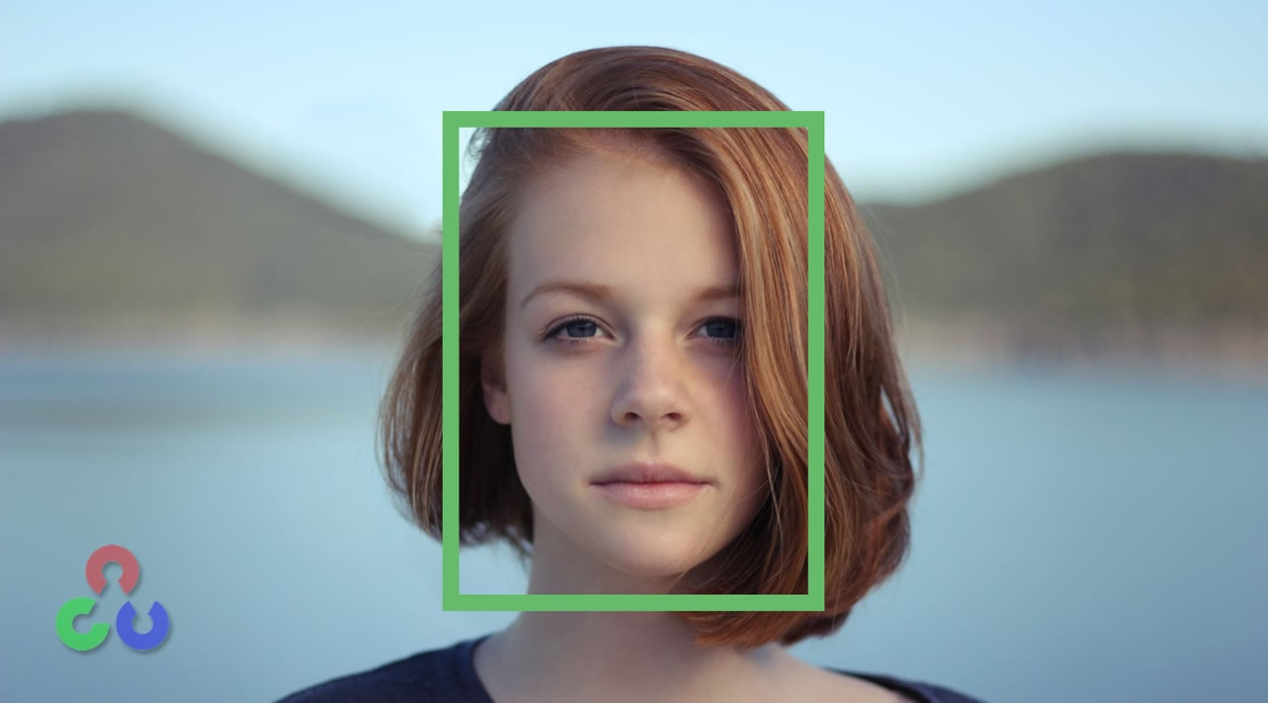

There are various applications of face detection, including camera autofocus, facial recognition, gender classification, landmark detection, and attendance recording. Camera autofocus assists the camera in focusing on the faces of the subject, while facial recognition helps in creating faceprint maps of facial features for identification purposes. Gender classification identifies the gender of a person based on facial features. Landmark detection is used to locate the key points of a face, such as eyes, nose, mouth, etc. Lastly, attendance recording can be done using face detection to keep a record of the presence of students or employees.

Face detection is the initial step in face analysis, face tracking, and, most importantly, face recognition. The facial recognition industry is rapidly expanding and being employed in various sectors, such as device unlocking, banking, hospitality, law enforcement, and building security. Face detection plays a crucial role in this industry as it enables facial recognition algorithms to identify which parts of an image should be used to create faceprints.

Face detection technology has several advantages and disadvantages. One of the primary benefits of face detection is that it enhances security measures and helps in the identification of terrorists and criminals. It is also easy to integrate with existing security software. Additionally, face detection allows for automated identification, which increases efficiency and accuracy.

However, there are also some disadvantages to face detection. One of the main drawbacks is the huge storage requirements needed for machine learning technology. Additionally, facial detection can be vulnerable and is dependent on factors like lighting, camera angle, and facial expressions, which can throw off the accuracy. Finally, there are potential privacy concerns around face detection and how it aligns with human privacy rights, which is a topic of ongoing debate.

**WORKING OF FACE DETECTION**

**Step 1:** Open the command prompt and write the following code: “pip install open_cv python”

**Step2:** Create a new Python file and import cv2. It is also called opencv and computer vision. It is used for image processing and computer vision. The process of cv are:-

Image Input

Extract pixels background the image

Resize the image

Face detection Algorithm

.

Result

**Steps3: #** Load the pre-trained Haar Cascade Classifier for face detection.

 'haarcascade_frontalface_default.xml’ is a file. The model is already trained in this file. We just have to testing the model in it.

**Steps4:** # Initialize the webcam

0 represents the default camera, change it if you have multiple cameras.

**Steps5:** Now, we will be use while loop condition **.**

The read variable indicates whether the webcam is read the frame or not. If true then capture the webcam otherwise, break.

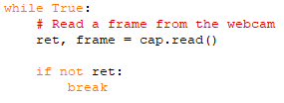

**Steps6:** # Convert the frame to grayscale for face detection.

If the image is being captured, the image will be converted to gray scale because face detection can be more efficiently working with gray scale.



**Steps7:** #Detect faces in the frame.

detectMultipleScale is a function . It handles different parameters like gray, scalefctor, minNeighbors, minSize.

scaleFactor value must be within 1.2 to 1.5. Whereas, minNeighbors means difference between the pixels of two different faces and the common adjacent rectangle gab value is 3 to 6 . minSize means minimum size of the frame in order to be detected.

**Steps8:** Now, we will draw rectangle around the faces detected. In this rectangle, we have given x,y,w, and h.

These are the four measurements of frame[(frame, (x,y) , (x+w , y+h) , (0,255,0) , 2)]. After uploading the image, the meaning of x and y axis will start by coordinating the top left corner of our image. (0,255,0) determines the colour of the rectangle. Whereas, 2 determine the stroke of the rectangle.

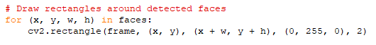

**Steps9:** We need to show the frame with detected faces with using function cv2.imshow. It means display the image in working environment. Then, we passing 2 arguments ‘Face detection’ determines the window name of the frame. In my project, I have used ‘s’ to terminate the loop. Waitkey means when we close the frame they will be pause the loop to 1 millisecond time and when the 0*FF ASCII code will match the ASCII code of ‘s’, Ultimately the loop will get terminated.

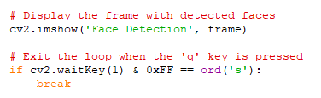

**Steps10:** Lastly, If we want to release the webcam we will use the cap.release( ) code and cv2 used for close or destroy all the open cv window.



**Result -**

**Input :-** face detection model.

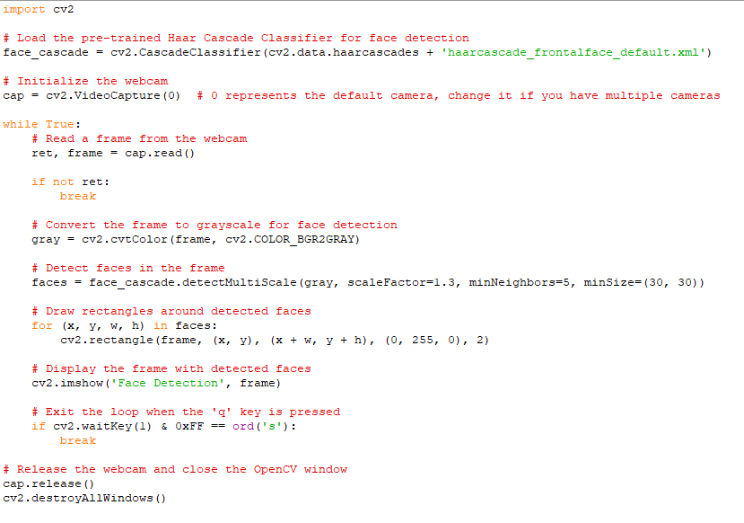

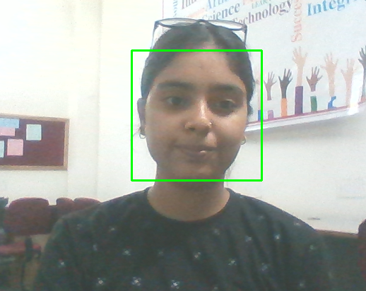**Output:-** face detection model.